Setup & Configuration:
- $ git –-version -> Check installed Git version.
- $ git config --global user.name "Yuvaraj S"
- $ git config --global user.email "mail2yuvarajs@gmail.com"
- $ git config --list -> View all configuration settings.

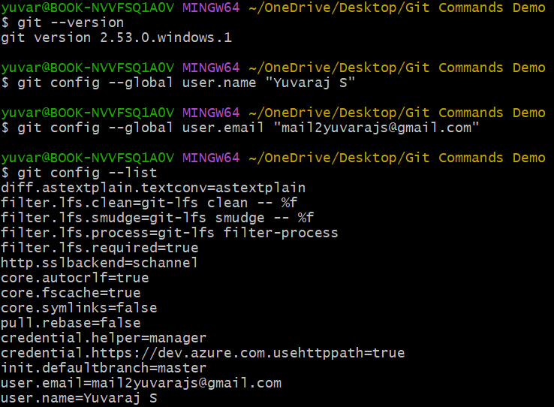

Repository Management:
Remote URL: https://github.com/yuvarajsscorpion/Git_and_GitHub_Commands_Demo.git
Git Repository: C:/Users/yuvar/OneDrive/Desktop/Git Commands Demo/.git/
- $ git init -> Initialize a new Git repository.
- $ git clone <remote url> -> Clone an existing repository from GitHub.
- $ git remote add origin <remote url> -> Link local repository to remote.
- $ git remote -v -> Show remote URL’s.

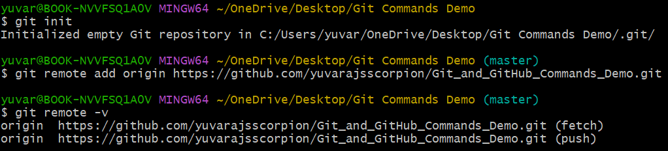

Branching & Merging:
- $ git branch -> List branches.
- $ git branch <name> -> Create a new branch.
- $ git checkout <name>” -> Switch to a branch.
- $ git switch <name>” -> Modern way to switch branches.
- $ git merge <name>” -> Merge another branch in to current.
- $ git branch -d <name>” -> Delete a branch

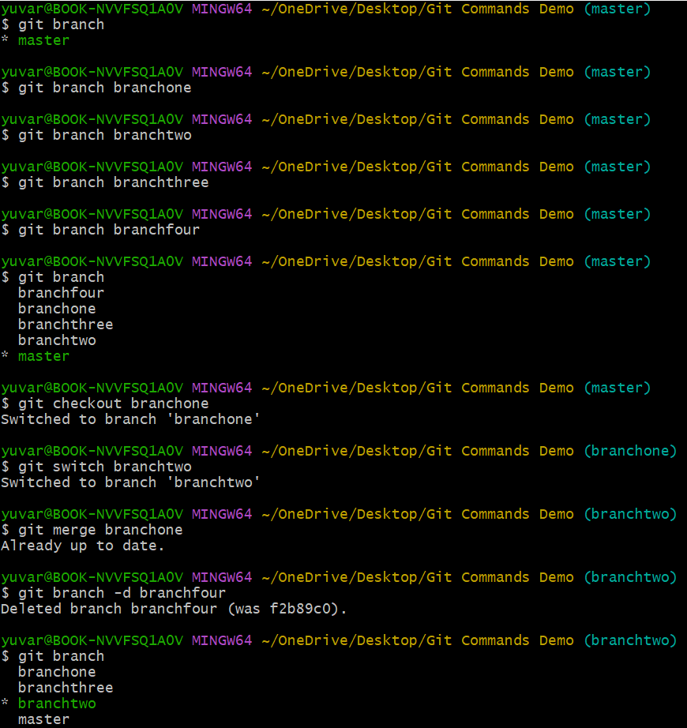
Staging & Committing:
- $ git status -> Show changes in working directory.
- $ git add <file name> -> Stage a file for commit.
- $ git commit -m “commit message” -> Commit staged changes with a message.

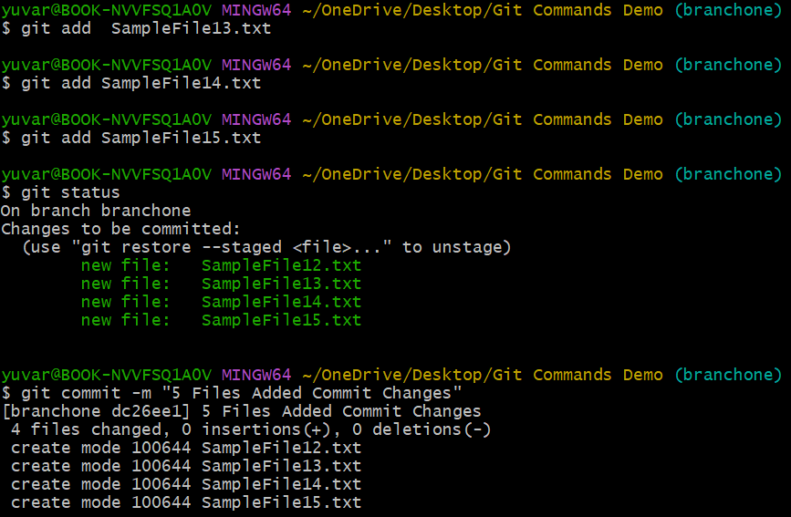

Undoing & Resetting:
- $ git reset <file> -> Unstage a file.
- $ git reset --hard -> Reset working directory to last commit.
- $ git revert <commit>” -> Create a new commit that undoes changes.
- $ git checkout -- <file>” -> Discard changes in a file.
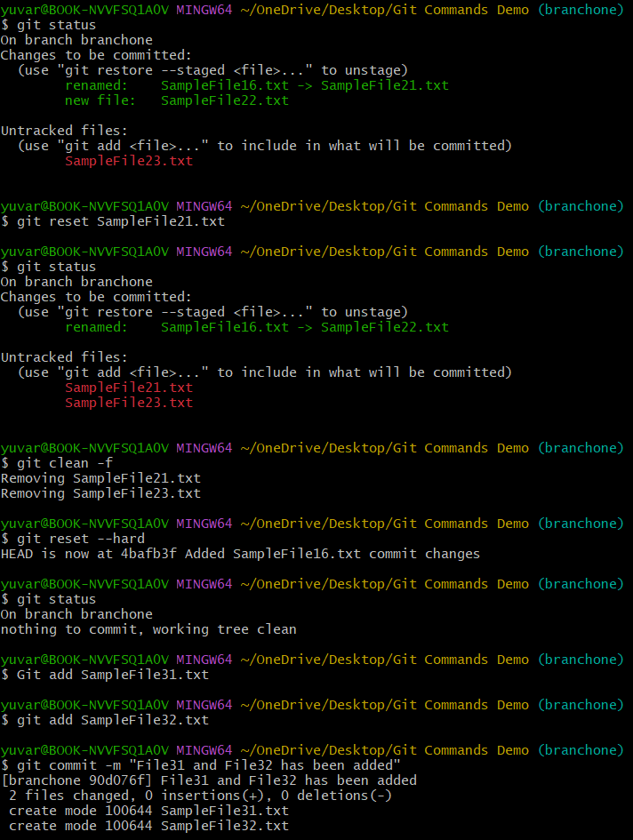
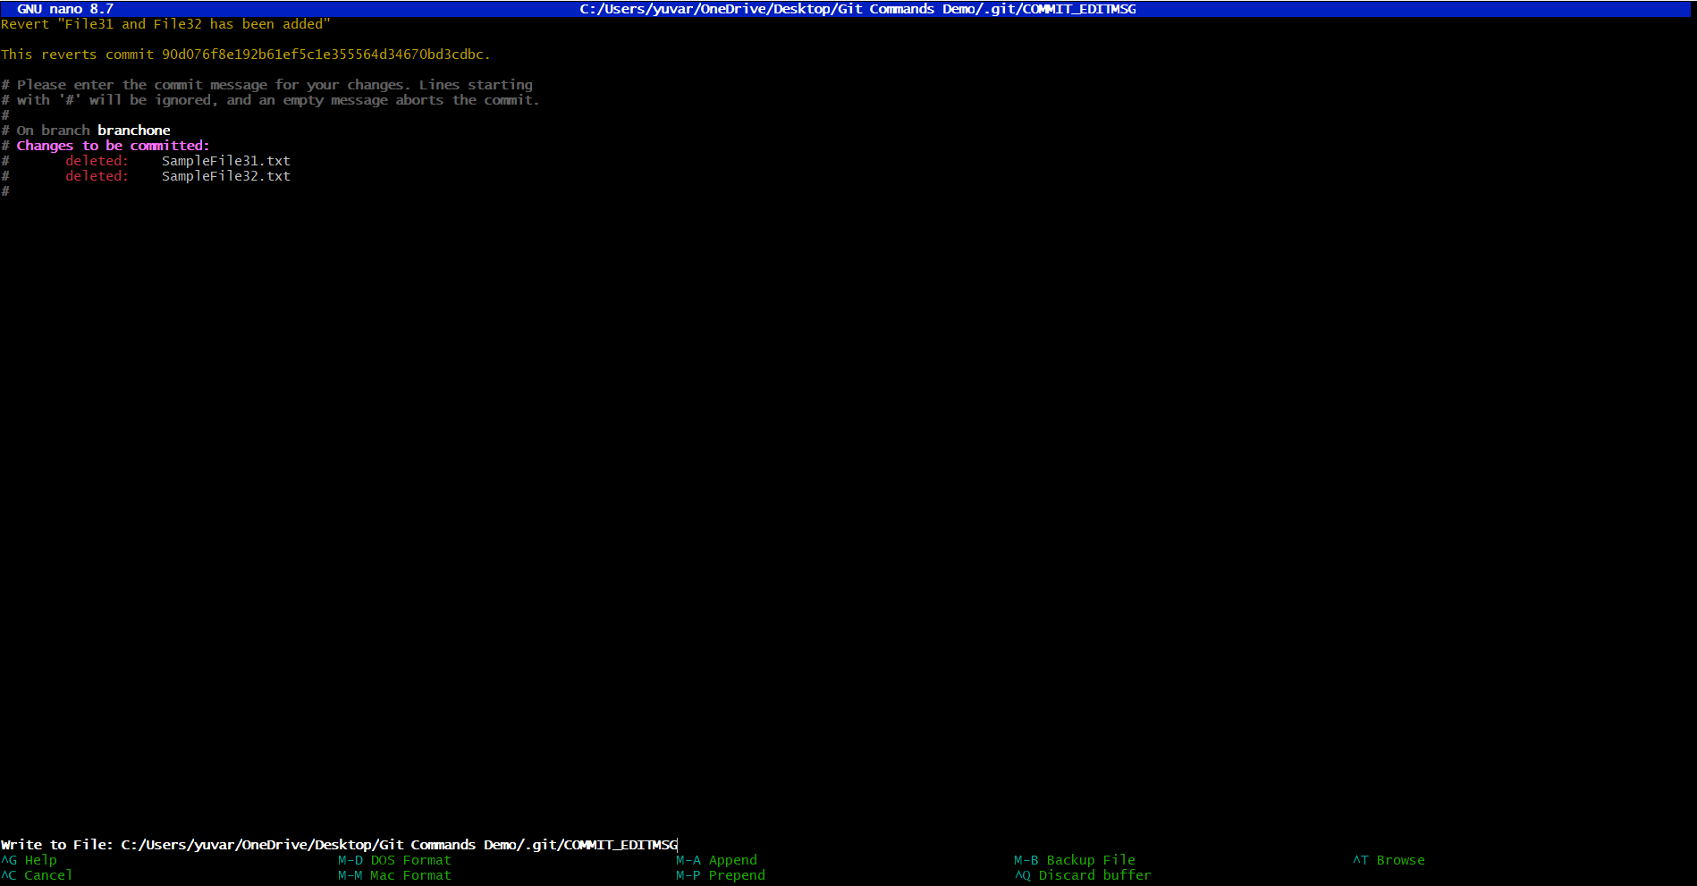
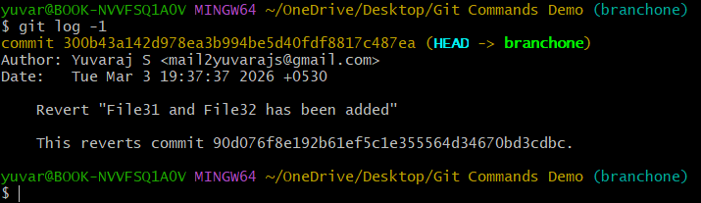

Pushing & Pulling:
- $ git push origin master -> push local commits to remote.
- $ git pull origin master -> Fetch and merge changes from remote.
- $ git fetch -> Download changes without merging.
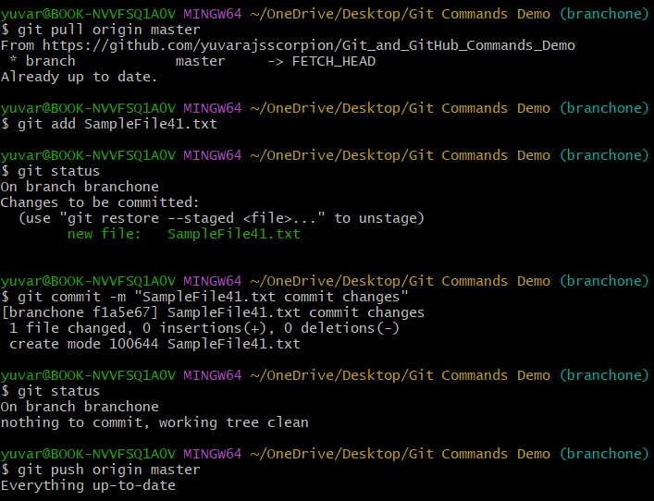

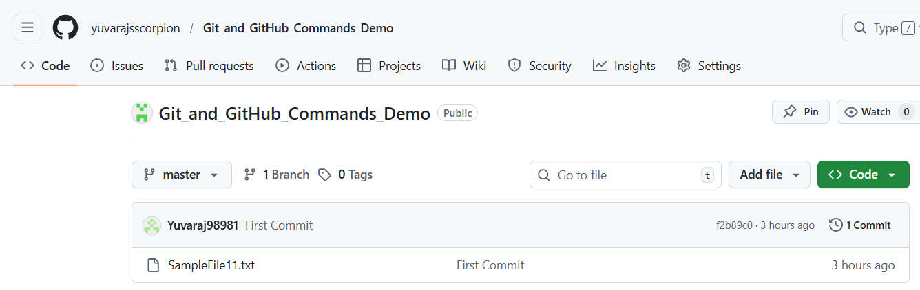

Cleaning & Maintenance:
- $ git log -> shows commit history.
- $ git diff -> shows difference between commits or working directory.
- $ git stash -> Temporarily save changes without committing.
- $ git clean-f -> Remove untracked/unstaged files.

